C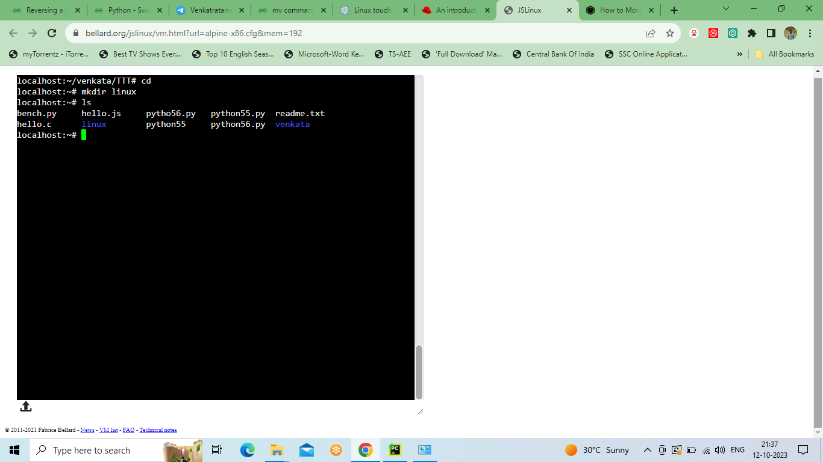

CREATING NEW DIRECTORY USING MKDIR AND ACCESING ALL FILES USING ;’LS’ COMMAND

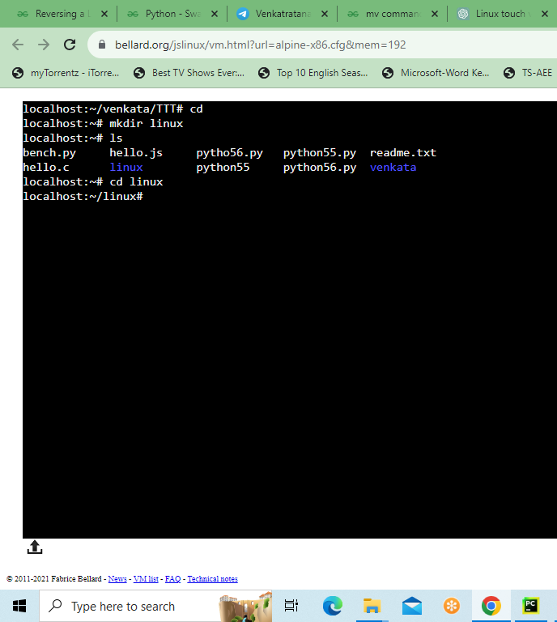

CHANGING DIRECTOEY USING CD COMMAND

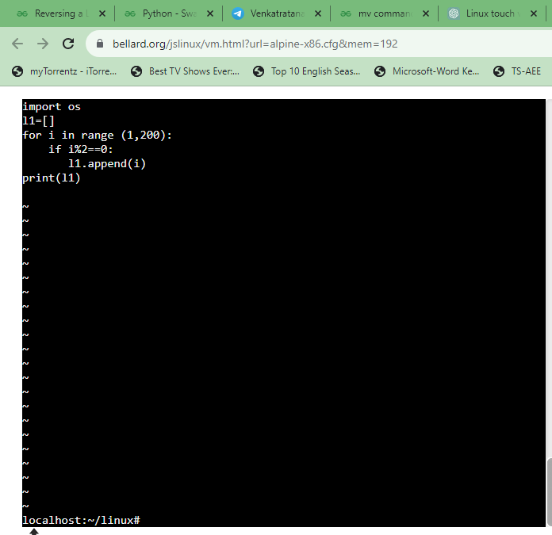

USING VI COMMAND CREATING FILE EXECUTING PYTHON PROGRAM
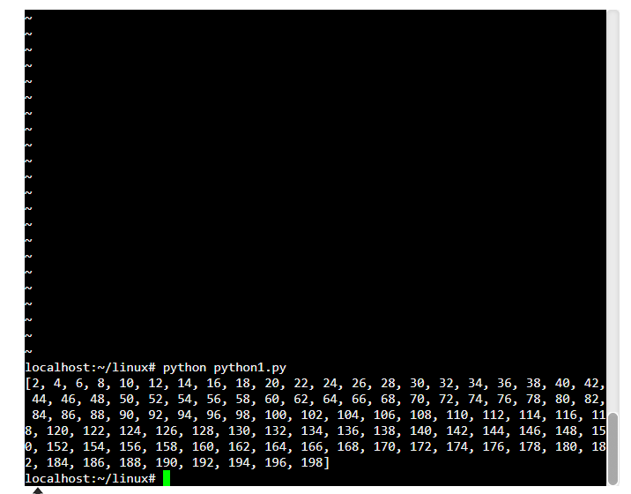
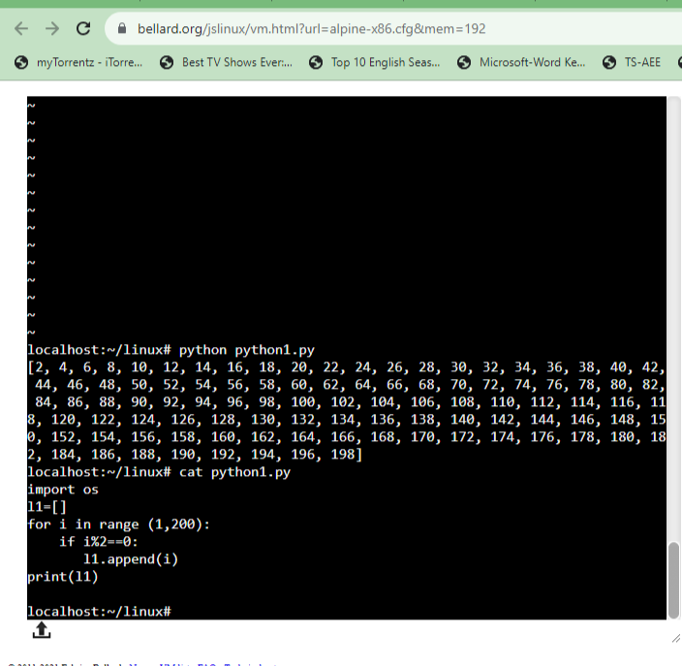

ACCESING SAVED FILE USING “CAT” COMMAND
“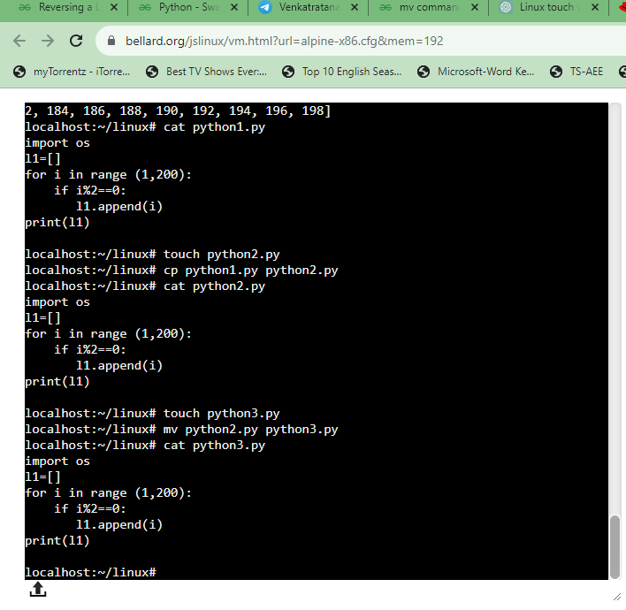

COPYING AND MOVING DATA FROM FILES USING CP AND MV COMMANDS

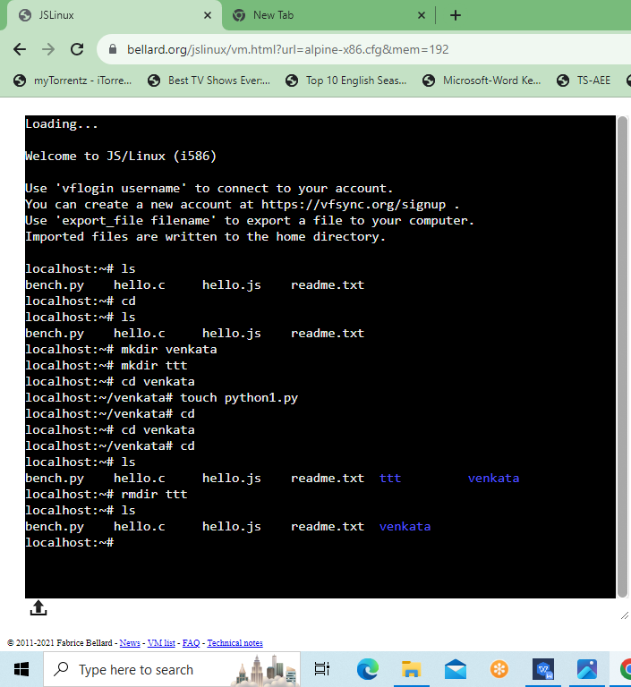
DELETING DIRECTORY USING RMDIR COMMAND

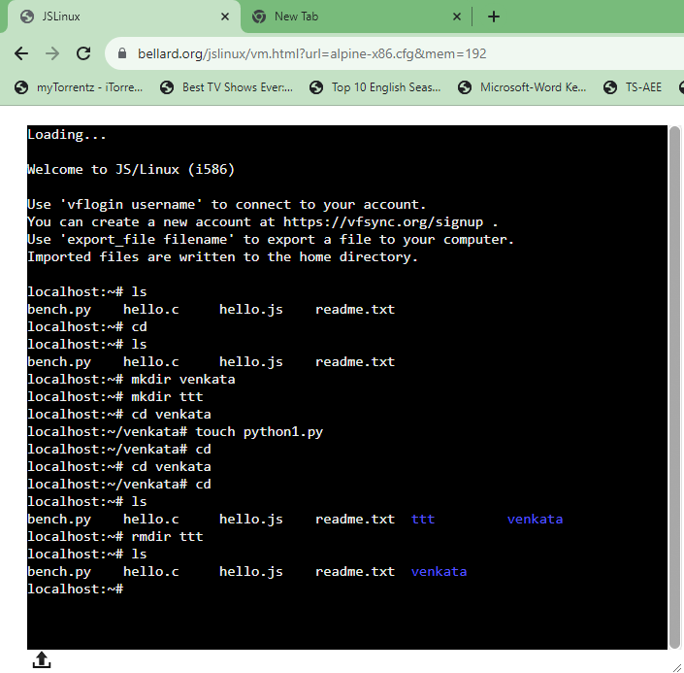
REMOVING FILE IN DIRECTORY USING RM COMMAND

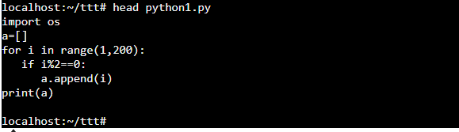
ACCESING DATA USING HEAD COMMAND
ACCESING DATA USING TAIL COMMAND
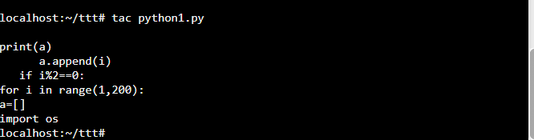
TAC COMMAND IS OPPOSITE TO CAT SHOWING DATA IN REVERSE

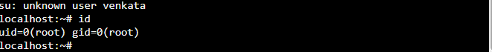
FINDING ID AND GID USING ID COMMAND

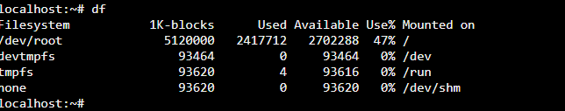

DF COMMANDTO ACCES FILE SYSYTEM DETAILS

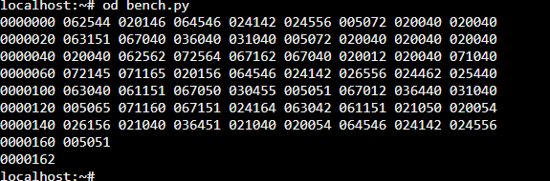

OD used to display the content of a file in different s, such as hexadecimal, octal, and ASCII characters.
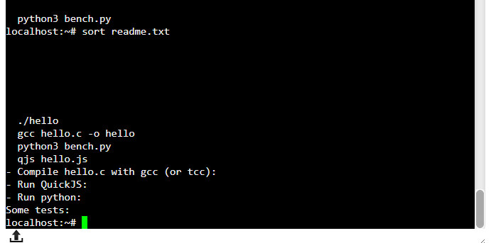
SORT COMMAND IS USED TO SORT DATA IN ALPHABETIC ORDER


DATE COMMAND TO DISPLAY DATE AND TIME

